27.11.2008
CSE221 DIGITAL LOGIC FUNDAMENTALS
Q3

10 | 1 | For the following Karnaugh map, find both minimum sum of products and minimum product of sums expressions.  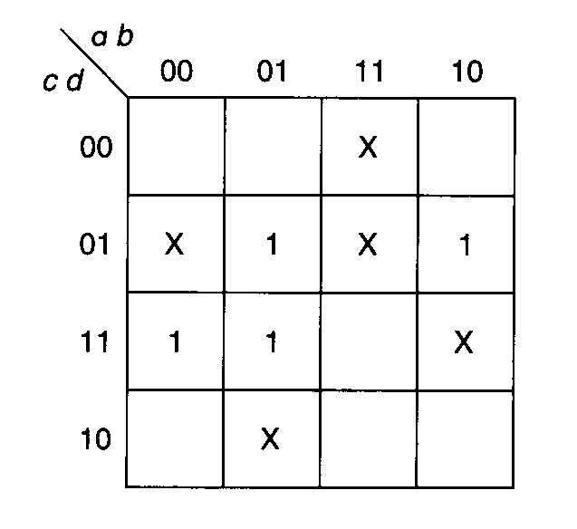
10 | 2 | Build a 16-way active high decoder, using only the four-way decoders shown below. The inputs are x, y, w and z; the outputs are numbered Q₀ to Q₁₆.  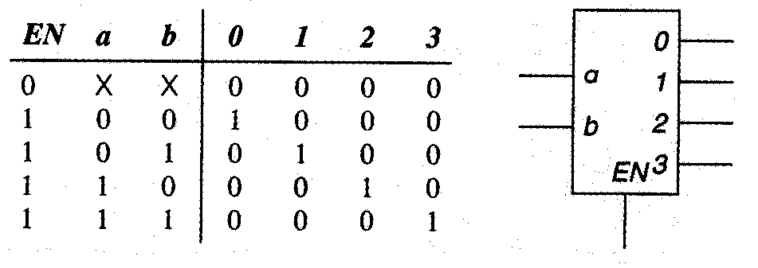
10 | 3 | The following 6-bit two’s complement numbers were found in a computer. What decimal number do they represent?  - 001011  - 111010

